This document is intended for customers licensed to use CCH Axcess™ Portal. The document is a template ready for customers to customize and distribute to their clients. To begin, search for “FirmName” and replace with the actual business name. Customize the cover page and text within the guide as appropriate to meet your firm policies. After the guide is customized it is recommended that the final document be converted to a PDF file for distribution to clients.

FirmName

CCH Axcess™ Portal Client User Guide
Subtitle

Last Updated: 3/15/2016

Icon Legend |  | Keys | Quick reference to the key aspects of a particular function
 |  | Tip | Best practice tips and shortcuts
 |  | Notes | Informational notes about functions
 |  | Warning | Important warnings about a function
What is a Portal?
Portals are web-based applications that allow for the encrypted, bi-directional transmission and storage of electronic data. In other words, you have instant access to documents and information wherever and whenever you want. A portal, is a place where files can be uploaded, downloaded, stored, and shared in a safe and secure environment — 24/7. Why is my accountant using a portal?
- It’s easy to use — This user guide contains simple instructions, but if you’ve ever used online banking or email, you’ll find your portal to be intuitive and easy to learn. Once we create your portal you will receive a few introductory email notifications with additional information and your specific login credentials.
- It’s secure — Portals are the most secure way to exchange documents electronically. With identity theft on the rise, portals provide you with peace of mind knowing that the only person who can access your files is you and anyone you designate.
- It’s convenient — Whether you want to locate last year’s tax return or need to urgently upload a file to send our way, you can do so – anytime, anywhere, thanks to 24/7 access. You won’t have to wait for the postal service or make a trip to our office — just log in and get to work. Share PDF files, Microsoft® Excel® spreadsheets, QuickBooks® company files, Microsoft® Word documents, Microsoft® PowerPoint® presentations and financial software data files — and more!

How Else Can I Use My Portal?
You have the capability to grant portal access to anyone — such as a banker who you may collaborate with on a regular basis. Prior to the convenience of portals, options to share information included email, fax, courier, or postal mail. In many cases, you had to request the information from our firm before you could provide it to the bank, and vice versa. Portals have significantly reduced the time and resources spent on trading information.
Your portal will also allow you to:
- Easily upload files of all sizes
- Designate files as read-only or read-write — having the option to disable others from overwriting changes, for added security
- Search, sort, and display documents based on a variety of characteristics

A portal will not only safely transmit your information but it will also help us foster better service, expanded communication, and faster/easier access to the information you seek, at anytime.

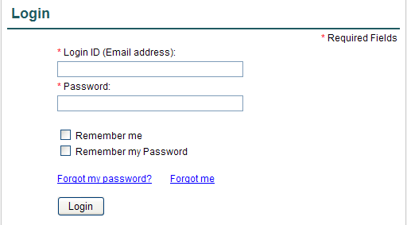
The Portal Interface
The interface is suitable for use on any computer and even your mobile/tablet devices. It provides a basic, web-based interface that allows you to use the core features efficiently, such as adding and downloading files.

A link to your portal is here: https://portal.cchaxcess.com/sui
Login Screen

Once you login, you’ll be directed to your personal, customized portal home page.

Portal Home Page
Your portal home page is where you will exchange documents with us.

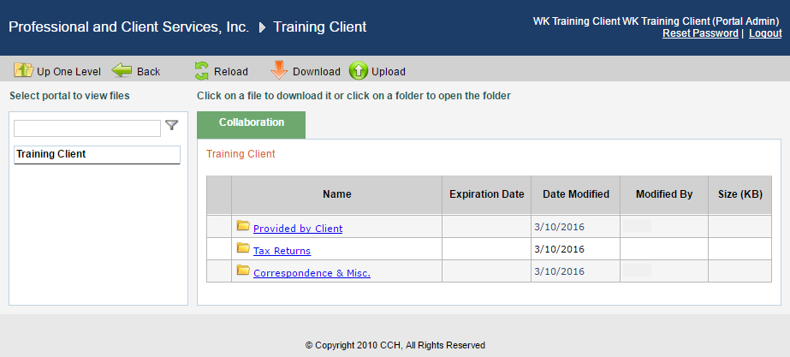
2
3
1
Portal Home Page

Home Page Key Features

- Menu Bar Used to navigate through Portal
- Navigation Pane Access a portal by clicking the portal name
- Files and Folders View the list of folders, and files within the folders

Menu Bar Key Features

Up One Level Move up one folder level within the files and folders.
Back Return to the previous screen.
Reload Refreshes the portal to reflect recent changes.
Download Click to download the selected file. Multiple files are downloaded as a single ZIP file. Select files to download by clicking the box to the left of the file name.
Upload Click Upload to add a file to the selected portal.

Download Files from Portal
A simple and easy way to download (view or save) a file is to click on the filename hyperlink. The file download prompt appears enabling the file to be saved or viewed.

Add Files to Portal
Click Upload in the menu bar to begin the process of adding files to the portal.

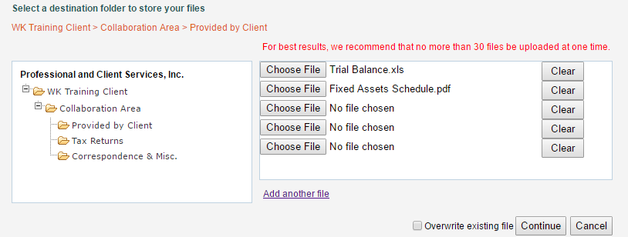
3
2
1
Add Files to Portal

Steps to add files to Portal
- In the folder selection pane, select the destination folder in Portal.
- Click Choose File and select file(s) to upload from your computer or network.
- Verify the file location and click Continue to add the file(s) to Portal.

